SPRINT-4

SPECIES IDENTIFICATION AND LOGOUT

|  |  |
| --- | --- |
| Date | 18 November 2022 |
| Team ID | PNT2022TMID30160 |
| Project Name | Digital Naturalist - AI Enabled Tool For  Biodiversity Researchers |

**PREDICT:**

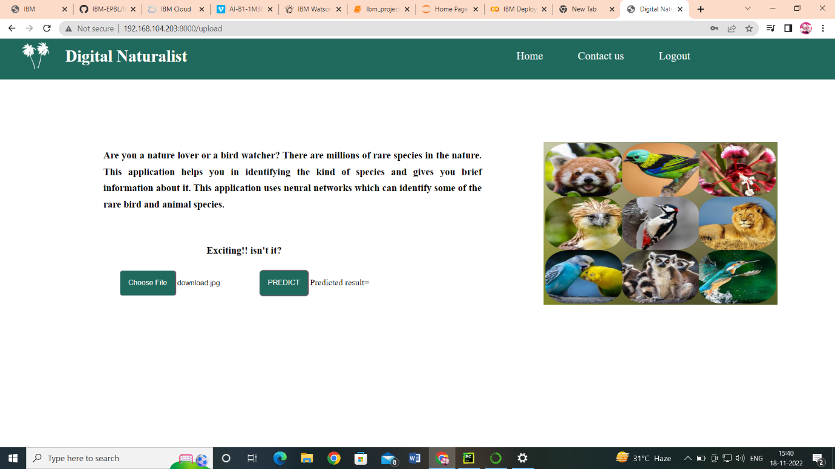

**upload the files:**

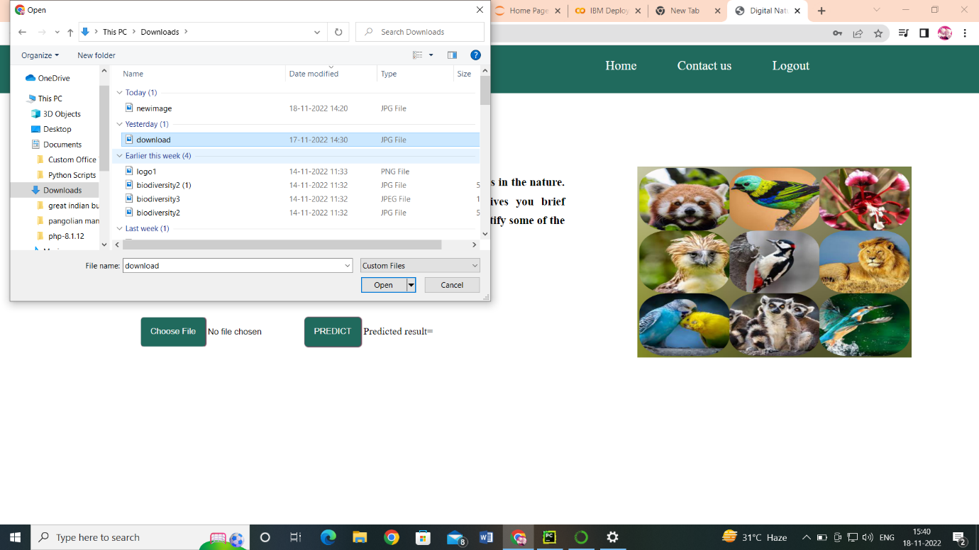

**After Predict the Species:**

